OMIS 673 MODULE 6 HOMEWORK

● You are now ready to manipulate and visualize the data.

* Add your full name to the title of each chart (e.g., Chart A by Young Lee). Otherwise, I will give you 0 points.
* Be sure to export your worksheets and insert them in this document.

**Visual 1**(20 points): Create your own chart, “2018 MA Motor Vehicle Accidents with Injury by County with Trauma”, covered in Video 6.2 (Advanced Map).

**Visual 2** (20 points):

1. Open Tableau. Under Connect Panel, under Saved Data Sources, select Sample- Superstore
2. Under Dimensions, expand “Location” to see the hierarchy of the geographical data. 3. Using the Superstore dataset, create a Symbol map with the following features.
   1. Sales of states are indicated by bubbles in different sizes. b. Only max and min Sales values are shown on the map.

c. States are filled with different colors to indicate different levels of White- Collar Occupations from 2018 U.S. Census Data.

1. Modify your chart so that it is clutter-free and confusion-free.
2. Which state does have the highest sales? Which state does have the lowest sales? Do you think there is any relationship between sales and white-collar occupations?

**Ans** The sales are highest in California. The lowest sales are in North Dakota. Yes, there is a connection between sales and white-collar jobs.

**Visual 3** (20 points):

1. Data>>New Data Source. Now under Saved Data Sources, select World Indicators
2. Using the Parameter Technique, Compare two filled maps for GDP and CO2 Emissions of countries
3. Pick two countries that show significant differences across the two filled map. What is your interpretation?

Ans. The two countries I chose are India and South Korea. There are differences in GDP and CO2 emission in these countries. The CO2 emission in India is 6,577,008 is more than the CO2 emission in South Korea (5,326,435). The GDP in south Korea is 11,590,000,000,000 which is less than the Indian GDP (13,898,000,000,000).

1. Please submit your twbx file for this Visual 3.



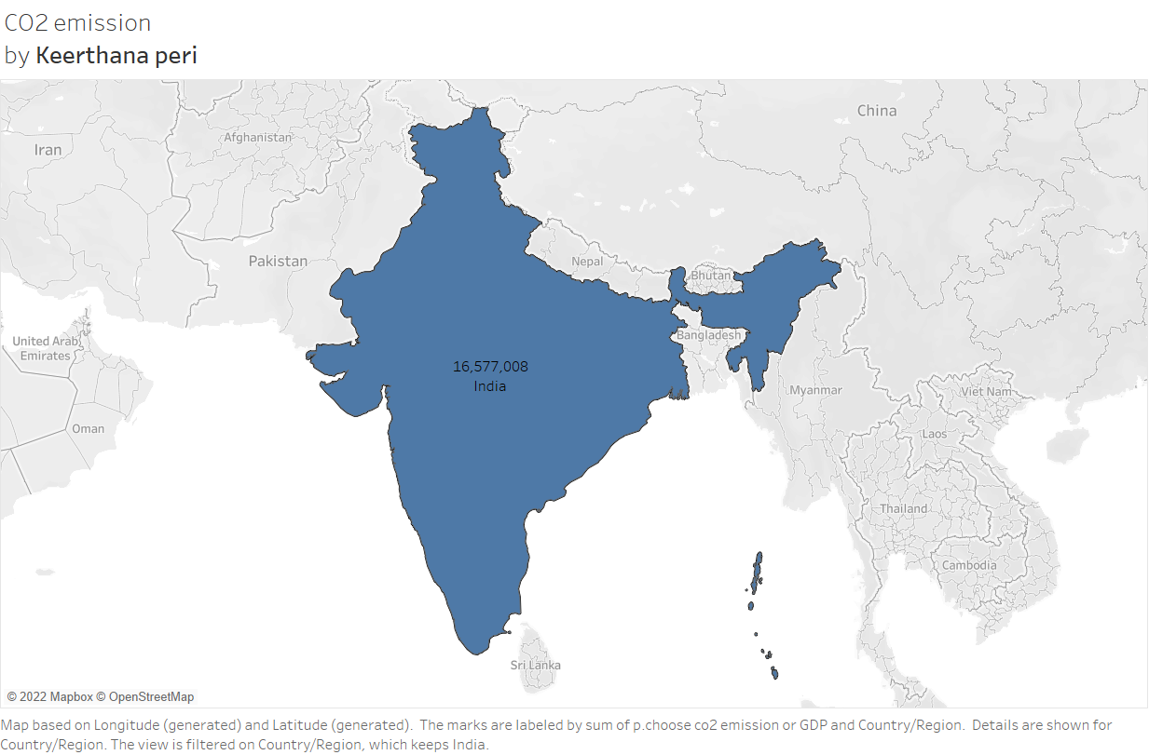

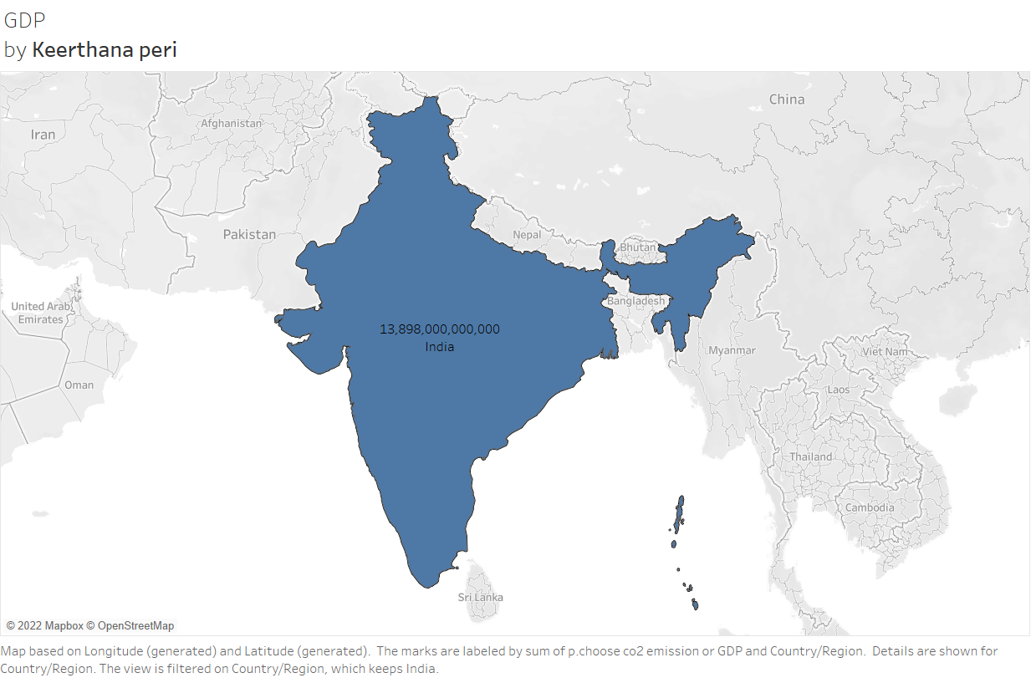

*1*